Methodology Section — Search Strategy and PRISMA Flow
AI-Assisted Programming in Software Engineering: A Systematic Literature Review
FROZEN METHODOLOGY — v4 (SciSpace-pipeline-accurate, sensitivity-tested)
Ready-to-insert text, PRISMA 2020 diagram, taxonomy table, and reproducible sensitivity appendix

1. PRISMA 2020 Flow Diagram
The figure below presents the complete PRISMA 2020 flow for this study, organised as a dual-pathway design. Branch A used the SciSpace AI-assisted academic discovery engine as the primary retrieval channel; SciSpace internally executed queries across three retrieval modes (its proprietary Deep Search, its Full-Text Search, and Google Scholar), producing 1,255 records that were reduced to 863 after internal deduplication. Branch B used author-executed direct queries on three academic databases (Scopus, ProQuest, and arXiv), producing 1,852 records. Both branches were screened against identical eligibility criteria and converged into an integrated dataset of 418 unique records from structured search. This dataset was distributed across operational sheets (Corpus, Related Work or Support, Duplicated, No Full Text, Excluded). A supplementary discovery pathway is reported explicitly for the nine records (four in Corpus, five in Related Work or Support) that entered the project through targeted gap-filling search, citation chasing, or opportunistic retrieval during full-text resolution.
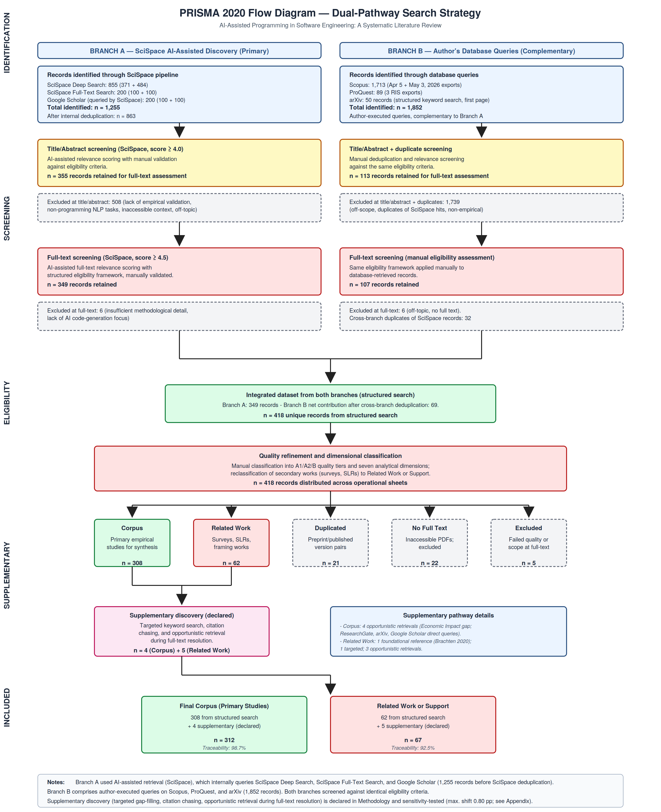
Figure 1. PRISMA 2020 dual-pathway flow diagram for the systematic literature review.

2. Methodology Text (Ready for Insertion)
The following subsections are drafted in publication-ready English and can be inserted directly into the Methodology section of the manuscript.

2.1 Search Strategy

Two complementary discovery pathways
The literature search combined two complementary discovery pathways. The primary pathway (Branch A) used SciSpace, an AI-assisted academic discovery engine, which orchestrates retrieval across multiple indexed sources. The complementary pathway (Branch B) used author-executed direct queries on three academic databases: Scopus, ProQuest, and arXiv. Both pathways targeted publications between 2021 and 2026, reflecting the emergence and rapid evolution of modern AI-assisted coding tools. Bibliographic information for individual papers was sometimes imported from publisher sites (IEEE Xplore, ACM Digital Library, SpringerLink, ACL Anthology); these channels served only as bibliographic-import mechanisms and are not counted as search sources, since the discovery of each such paper had already occurred on one of the four search sources above.

Branch A — SciSpace AI-assisted retrieval
A structured search instruction was provided to SciSpace specifying the review topic, research questions, the time window, inclusion and exclusion criteria, required output fields, and quality-control constraints. SciSpace executed the instruction across three internal retrieval modes: (i) SciSpace Deep Search (855 records from two semantic queries: 371 + 484), (ii) SciSpace Full-Text Search (200 records from two queries: 100 + 100), and (iii) Google Scholar, queried programmatically by SciSpace as part of its retrieval pipeline (200 records from two queries: 100 + 100). The combined identification yielded 1,255 records, reduced to 863 unique records after SciSpace's internal deduplication. These records were then carried through the two-stage SciSpace screening pipeline (title/abstract scoring with a cutoff of 4.0, followed by full-text scoring with a cutoff of 4.5), with each AI-assisted decision validated manually by the author against the eligibility criteria. This branch retained 355 records at title/abstract screening and 349 records at full-text screening. The complete archive of SciSpace's search outputs (query logs, retrieved record CSVs, and screening artifacts) is preserved as supplementary material.

Branch B — Author's database queries
The author-executed database pathway returned 1,852 records across three sources: 1,713 from Scopus (two exports, dated April 5 and May 3, 2026), 89 from ProQuest, and 50 records browsed on arXiv through a structured keyword search combining AI-assisted-programming, software-engineering, and outcome-related terms (arXiv displays 50 records per result page; the search yielded a single page of results relevant to the review scope). After title/abstract screening (113 retained) and full-text assessment (107 retained), cross-branch deduplication against the SciSpace branch removed 32 duplicate records, yielding a net contribution of 69 unique records. Search strings, filters, and export timestamps for each query are preserved in the supplementary materials of the project.

Convergence
The two branches converged into an integrated dataset of 418 unique records from structured search (349 from Branch A and 69 net from Branch B). This dataset was then subjected to manual quality refinement and dimensional classification before distribution across the operational sheets described in Section 2.4.

2.2 Use of Artificial Intelligence in the Review Process
Artificial intelligence tools were used to support specific tasks in the review process. SciSpace functioned as an AI-assisted discovery engine — orchestrating queries across its proprietary semantic indexes, full-text search, and Google Scholar — and as a first-pass relevance scorer for title/abstract and full-text screening. Decisions emitted by SciSpace were treated strictly as assistive recommendations: every inclusion, exclusion, classification, and quality-assessment decision was validated and recorded manually by the author. AI tools were not used to perform synthesis, data extraction, or interpretation of findings.

2.3 Inclusion and Exclusion Criteria
Eligibility criteria were applied identically to both branches and at every screening stage. Studies were included if they reported empirical evaluation (quantitative, qualitative, or mixed-methods) of AI-assisted programming or code generation; evaluated modern AI tools (Copilot, ChatGPT, Codex, Gemini, Claude Code, CodeWhisperer, Cursor, or comparable systems); reported results allowing analytical interpretation; were published between 2021 and 2026; and were written in English. Studies were excluded if they were opinion papers without empirical content, focused on unrelated NLP tasks, were duplicates of records already accepted from another source, or fell outside the topical scope of AI-assisted software development. Surveys, systematic literature reviews, and conceptually adjacent works were reclassified to the Related Work or Support set rather than discarded, in order to preserve their contribution to the framing of the synthesis.

2.4 Operational Taxonomy of Records
To maintain a transparent and auditable separation between evidence used for synthesis and evidence used for framing, each retained record was assigned to one of five operational categories. The following table defines each category and its role in the synthesis.
Category | Purpose | Included in synthesis? | Count (n)
Corpus | Primary empirical evidence base. Studies with empirical results directly analysed across the seven dimensions, weighted by epistemic segmentation (CORE / SUPPORTING / PERIPHERAL). | Yes — quantitative and narrative synthesis | 312
Related Work or Support | Surveys, systematic reviews, and conceptually adjacent works providing theoretical and contextual grounding. Cited in Introduction and Discussion, but not counted in corpus statistics. | No — framing and grounding only | 67
Duplicated | Preprint/published-version pairs of records already represented in another sheet (internal SciSpace duplicates). Retained for audit transparency. | No | 21
No Full Text | Records whose full text could not be retrieved; excluded from empirical analysis but retained for traceability. | No | 22
Excluded | Records that entered the structured screening pipeline but failed quality or scope criteria at full-text assessment. | No | 5
Within the Corpus, a further epistemic segmentation (CORE = 168, SUPPORTING = 120, PERIPHERAL = 18, REMOVE_CANDIDATE = 6) governs interpretive weight: all descriptive statistics are computed over the full Corpus (n = 312), while strong claims are preferentially anchored in CORE studies and triangulated with SUPPORTING evidence.

2.5 Study Selection Process
The selection process followed the four-phase PRISMA 2020 framework (Identification, Screening, Eligibility, Inclusion) and was applied to both branches in parallel. After identification (1,255 records returned by the SciSpace pipeline, reduced to 863 after its internal deduplication; plus 1,852 author-retrieved database records), title/abstract screening retained 355 records from Branch A and 113 from Branch B. Full-text screening retained 349 records from Branch A and 107 from Branch B. Cross-branch deduplication removed 32 database records that duplicated SciSpace hits, yielding a net Branch B contribution of 69 records. The integrated structured-search dataset thus comprised 418 unique records, distributed across the five operational sheets defined in Section 2.4 (Corpus 308, Related Work or Support 62, Duplicated 21, No Full Text 22, Excluded 5).

2.6 Supplementary Discovery
In addition to the two structured pathways, a supplementary discovery procedure was applied selectively to address residual gaps and to preserve methodological transparency. This procedure covered three situations: (i) targeted keyword search prompted by gap diagnosis when a specific analytical dimension showed insufficient empirical depth; (ii) citation chasing from references in already-retrieved papers; and (iii) opportunistic retrieval during full-text resolution, including cases where related-link panels or alternative result lists surfaced conceptually relevant works. All such candidates were subjected to the same eligibility criteria and quality-assessment framework as papers retrieved through the structured pathways. After this procedure, four primary studies were added to the Corpus (4 of 312, or 1.3%) and five additional studies were added to Related Work or Support (5 of 67, or 7.5%). One foundational study published in 2020 (Brachten et al., on cognitive-load reduction by virtual agents) was retained explicitly as a Related Work reference providing the conceptual basis for the cognitive-load–performance relationship subsequently extended by the field toward AI-assisted coding tools; it is not counted in the empirical corpus statistics.

2.7 Reproducibility and Audit Trail
All search exports and the integrated relation of studies are preserved as supplementary materials, including SciSpace's complete pipeline artifacts (semantic-search CSVs, full-text-search CSVs, Google Scholar query CSVs internally executed by SciSpace, abstract- and full-text-screening CSVs, and SciSpace's own PRISMA documentation). Of the 312 primary studies in the final Corpus, 308 (98.7%) are directly traceable to documented structured-search outputs; of the 67 papers in Related Work or Support, 62 (92.5%) are similarly traceable; and all 5 papers in the Excluded set are traceable to structured queries. The 9 papers that entered the project through supplementary discovery are listed individually in Supplementary Table SX with their provenance recorded. A traceability audit and the full archive of search outputs allow any reviewer to verify the origin of each record.

3. Supplementary Table SX — Papers Added via Supplementary Discovery
This table provides the full audit trail for the nine papers (four in Corpus, five in Related Work or Support) that entered the project through supplementary discovery rather than through structured-search outputs. Note that Google Scholar references in this table denote queries executed directly by the author, distinct from the Google Scholar queries internally executed by SciSpace as part of Branch A.
Sheet | Bibkey | Year | Class. | Primary Dim. | Discovery type | Provenance note
Corpus | rodriguez_comparative_2025 | 2025 | B | Economic Impact | Opportunistic retrieval | Identified on ResearchGate during full-text resolution of another paper; targeted retention given the Economic Impact dimension gap.
Corpus | zhang_are_2025 | 2025 | A2 | CQTD | Opportunistic retrieval | Identified during arXiv browsing while resolving another paper.
Corpus | li_exploring_2025 | 2025 | A2 | Productivity | Opportunistic retrieval | Identified in Google Scholar (direct author query) while verifying an erroneous reference returned by an external AI tool.
Corpus | bonin_exploring_2025 | 2025 | B | Organizational Impact | Opportunistic retrieval | Identified in Google Scholar (direct author query); record hosted on SSRN.
Related Work | brachten_ability_2020 | 2020 | A2 | — (foundational) | Foundational reference | Out of the 2021–2026 window; addresses virtual assistants rather than coding tools. Retained as a conceptual anchor for the cognitive-load–performance relationship.
Related Work | hutter_agentstepper_2026 | 2026 | — | — (adjacent) | Targeted | Identified through Google Scholar (direct author query) with keywords derived from a gap-diagnosis exercise on debugging behaviour.
Related Work | zhang_trust_2023 | 2023 | — | — (adjacent) | Opportunistic retrieval | Identified via the related-links feature of ScienceDirect during full-text resolution of another paper.
Related Work | modi_measuring_2026 | 2026 | — | — (adjacent) | Opportunistic retrieval | Identified in Google Scholar (direct author query) while verifying an erroneous reference returned by an external AI tool.
Related Work | salmo_application_2024 | 2024 | — | — (grey literature) | Opportunistic retrieval | Identified in Google Scholar (direct author query) while verifying an erroneous reference returned by an external AI tool; institutional repository (University of Vaasa, Osuva).

4. Source-Level Record Counts
The following table reports record counts at each search source. Bibliographic import channels (IEEE Xplore, ACM Digital Library, SpringerLink, ACL Anthology) are listed for transparency but are not counted as search sources — each was used solely to import the bibliographic record of a paper whose discovery had occurred on one of the four search databases.
Source / Database | Records identified | Output format(s) | Role in dual-pathway design
SciSpace pipeline (Branch A) | 1,255 | Multiple CSVs (per query) | Primary AI-assisted retrieval
→ SciSpace Deep Search | 855 | 2 CSVs (queries 1 & 2) | Branch A — semantic search
→ SciSpace Full-Text Search | 200 | 2 CSVs (queries 1 & 2) | Branch A — full-text search
→ Google Scholar (queried by SciSpace) | 200 | 2 CSVs (queries 1 & 2) | Branch A — internal Google Scholar pipeline
Scopus (author query) | 1,713 | 1 RIS (Apr 5) + 1 CSV (May 3) | Branch B — main database
ProQuest (author query) | 89 | 3 RIS exports | Branch B — complementary
arXiv (author query) | 50 | no export (single results page browsed) | Branch B — complementary
Supplementary discovery | 9 | — (not from structured search) | Targeted gap-filling, citation chasing, opportunistic retrieval
IEEE Xplore (import only) | — | individual RIS for bibliographic import | Not a search source
ACM Digital Library (import only) | — | individual BibTeX for bibliographic import | Not a search source
SpringerLink (import only) | — | individual RIS for bibliographic import | Not a search source
ACL Anthology (import only) | — | individual ENDF for bibliographic import | Not a search source
Note: The three sub-rows under the SciSpace pipeline reflect SciSpace's internal retrieval architecture as documented in its search strategy. SciSpace combines its proprietary indexes with Google Scholar queries to provide comprehensive coverage; this Google Scholar usage is distinct from author-executed Google Scholar queries, which are reported under supplementary discovery. SciSpace performs internal deduplication; the 1,255 figure reflects the pre-deduplication pool, reducing to 863 unique records before screening. Cross-branch deduplication (Branch A vs. Branch B) removed 32 additional duplicate records at the eligibility stage. The arXiv search did not generate an export file; the 50-record count reflects the records returned on the first (and only) results page of a single structured keyword query.

5. Threats to Validity Paragraph (addition)
The following paragraph should be added to the Threats to Validity section to address reproducibility concerns related to supplementary discovery.
A potential threat to reproducibility arises from the nine papers added through supplementary discovery (targeted gap-filling, citation chasing, and opportunistic retrieval during full-text resolution). A researcher applying only the structured queries described in the Search Strategy might not retrieve these specific studies. To mitigate this threat, all nine supplementary papers are listed in Supplementary Table SX with their provenance, and the complete archive of search outputs is preserved as supplementary material. A sensitivity analysis (Section 6) confirms that the principal findings are robust to the exclusion of the supplementary papers: when the four Corpus-level supplementary studies are removed, no reported percentage — across dimensional distribution, quality classification, epistemic segmentation, or publication year — shifts by more than 0.80 percentage points. The traceability rate of the final corpus against documented structured-search outputs is 98.7% (308 of 312), which we consider an adequate audit standard for a multi-pathway systematic review of this scale.

6. Reproducible Sensitivity Analysis (Appendix)
This appendix reports the full sensitivity analysis underpinning the robustness claim in Section 5. Each axis is recomputed for the full Corpus (n = 312) and for the Corpus with the four supplementary studies removed (n = 308). The reported delta is the absolute change in percentage points (pp).

6.1 Primary Dimension Distribution
Dimension | n = 312 | n = 308 | Δ (pp)
Productivity | 26 (8.33%) | 25 (8.12%) | -0.22
Code Quality & Technical Debt | 141 (45.19%) | 140 (45.45%) | +0.26
Human–AI Interaction | 115 (36.86%) | 115 (37.34%) | +0.48
Perception & Trust | 13 (4.17%) | 13 (4.22%) | +0.05
Cognitive Load / Human Factors | 9 (2.88%) | 9 (2.92%) | +0.04
Organizational Impact | 7 (2.24%) | 6 (1.95%) | -0.3
Economic Impact | 1 (0.32%) | 0 (0%) | -0.32
Maximum absolute shift on this axis: 0.48 pp.

6.2 Quality Classification
Class | n = 312 | n = 308 | Δ (pp)
A1 | 146 (46.79%) | 146 (47.4%) | +0.61
A2 | 132 (42.31%) | 130 (42.21%) | -0.1
B | 34 (10.9%) | 32 (10.39%) | -0.51
Maximum absolute shift on this axis: 0.61 pp.

6.3 Epistemic Segmentation
Segment | n = 312 | n = 308 | Δ (pp)
CORE | 168 (53.85%) | 166 (53.9%) | +0.05
PERIPHERAL | 18 (5.77%) | 17 (5.52%) | -0.25
REMOVE_CANDIDATE | 6 (1.92%) | 6 (1.95%) | +0.02
SUPPORTING | 120 (38.46%) | 119 (38.64%) | +0.17
Maximum absolute shift on this axis: 0.25 pp.

6.4 Publication Year
Year | n = 312 | n = 308 | Δ (pp)
2022 | 6 (1.92%) | 6 (1.95%) | +0.02
2023 | 34 (10.9%) | 34 (11.04%) | +0.14
2024 | 120 (38.46%) | 120 (38.96%) | +0.5
2025 | 121 (38.78%) | 117 (37.99%) | -0.8
2026 | 31 (9.94%) | 31 (10.06%) | +0.13
Maximum absolute shift on this axis: 0.8 pp.
Global maximum shift across all four axes: 0.8 percentage points. This confirms that the inclusion of supplementary studies does not materially alter the empirical profile of the corpus, and that all principal findings hold whether or not these studies are included.

